**Online Shopping System**

**Software Requirement Specification (SRS)**

**by**

**Waqar Ali khan**

Date:

**1. Introduction:**

**1.1 Purpose**

This document is meant to delineate the features of Online Shopping System (OSS), so as to serve as a guide to the developers on one hand and a software validation document for the prospective client on the other. The Online Shopping System (OSS) for electronics item shop web application is intended to provide complete solutions for vendors as well as customers through a single get way using the internet. It will enable vendors to setup online shops, customer to browse through the shop and purchase them online without having to visit the shop physically. The administration module will enable a system administrator to approve and reject requests for new shops and maintain various lists of shop category.

**1 .2 Scope**

This system allows the customers to maintain their cart for add or remove the product over the internet.

**1 .3 Definitions**

OSS- Online shopping System (for electronics item shop)

SRS- Software Requirement Specification

GUI- Graphical User Interface

Stockholder- The person who will participate in system

Ex. Customer, Administrator, Visitor etc.

* 1. **References:**

1. [www.daraz.pk](http://www.daraz.pk)
2. [www.ebay.com](http://www.ebay.com)
3. [www.yavo.com](http://www.yavo.com)
4. [www.**HomeShopping.pk**](http://www.HomeShopping.pk).
5. [www.Olx.com.pk](http://www.Olx.com.pk)
6. [www.pakwheels.com](http://www.pakwheels.com)
7. [www.zameen.com](http://www.zameen.com)
8. [www.kaymu.com](http://www.kaymu.com)
9. [www.shophive.com](http://www.shophive.com)
10. [www.symbios.pk](http://www.symbios.pk)

**2. System Overview:**

This system provides an easy solution for customers to buy the product without going to the shop and also to shop owner to sale the product. This proposed system can be used by any naïve users and it does not require any educational level, experience or technical expertise in computer field but it will be of good use if user has the good knowledge of how to operate a computer.

**2.1 Product Perspective:**

This product aimed toward a person who don’t want to visit the shop as he might don’t get time for that or might not interested in visiting there and dealing with lot of formalities.

**2.2 Product Functions**

OSS should support this use case:

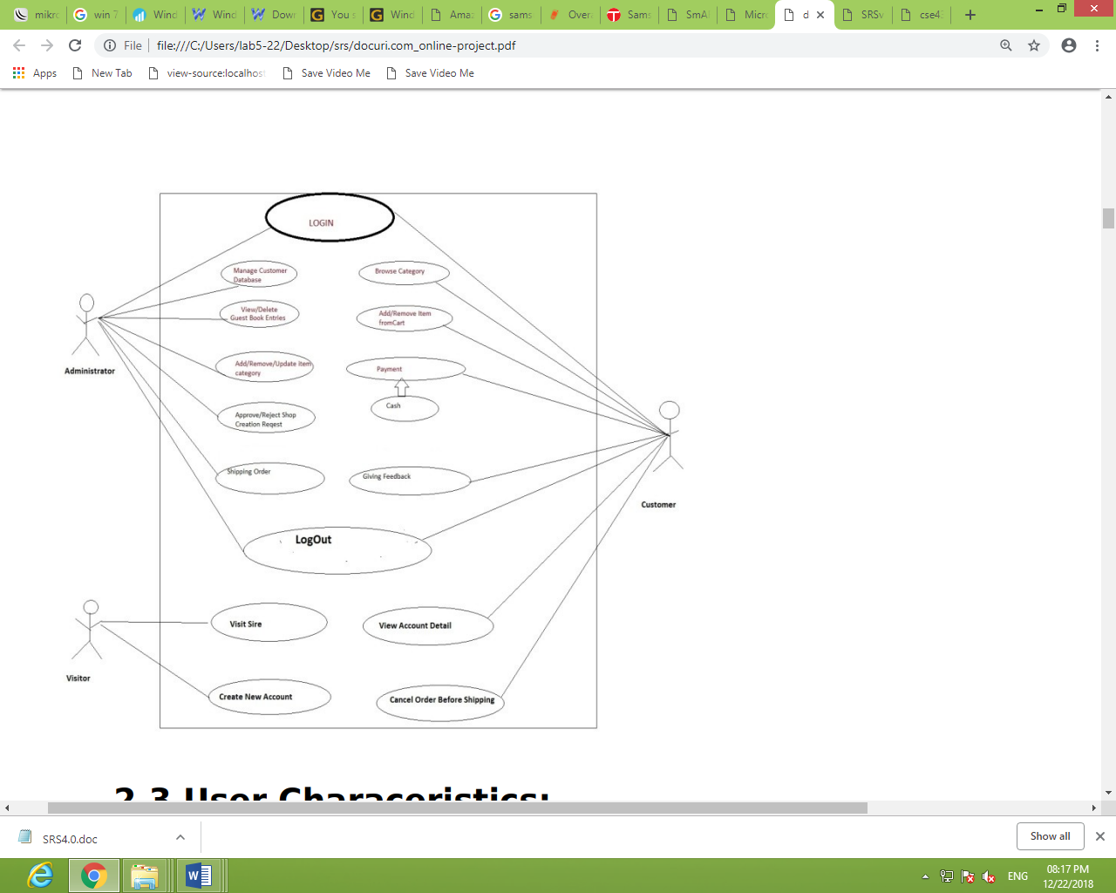

**2.3 User Characteristics:**

User should be familiar with the terms like login, register, order system etc.

**2.4 Principle Actors:**

Principle Actors are Customer and Administrator.

**2.5 General Constraints:**

A full internet connection is required for OSS.

**2.6 Assumptions and Dependencies:**

Working of OSS need Internet Connection.

**3. Use case diagrams**

OSS usecase diagrams are:

**3.1 Class Diagram**

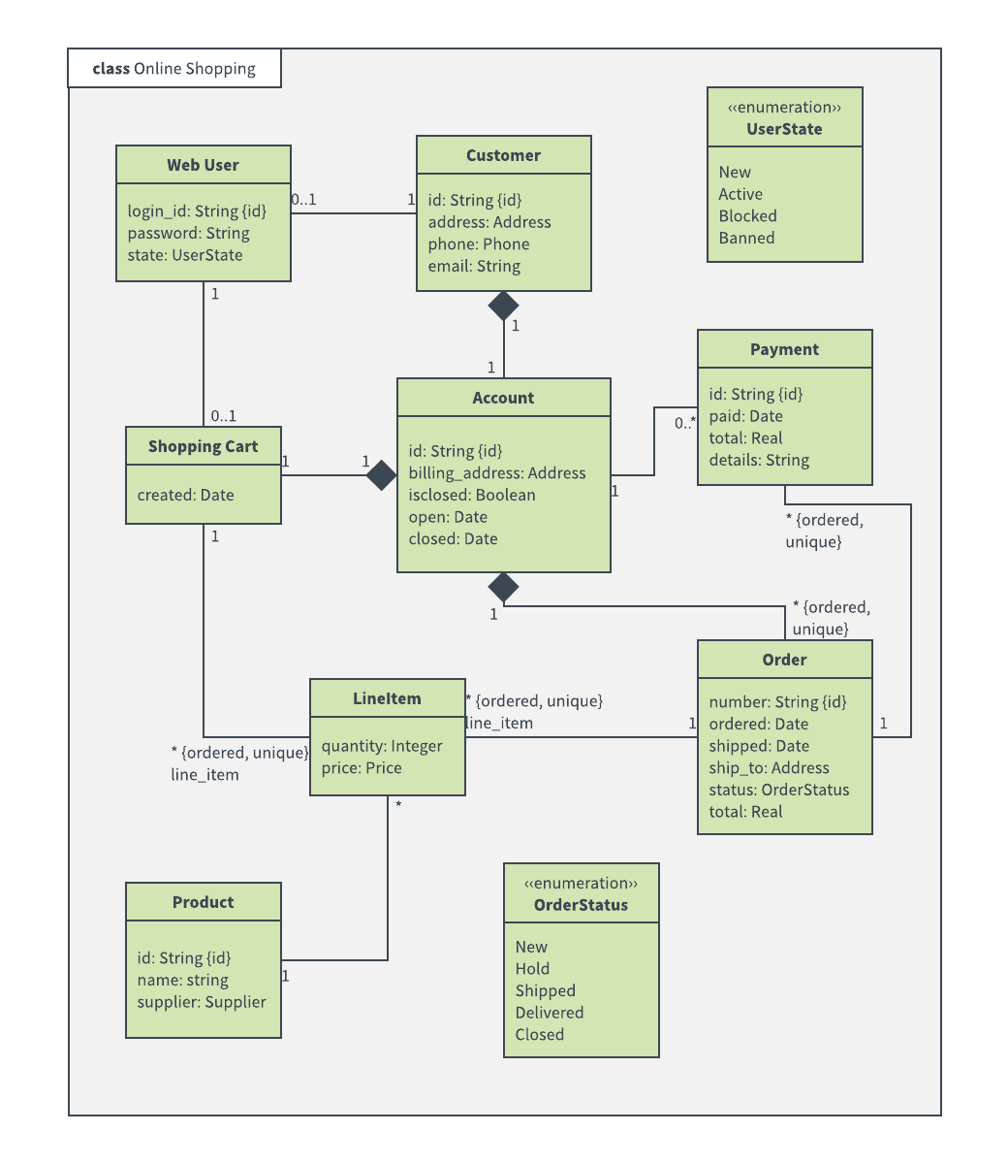

**3.2 Activity Diagram of the Customer side**

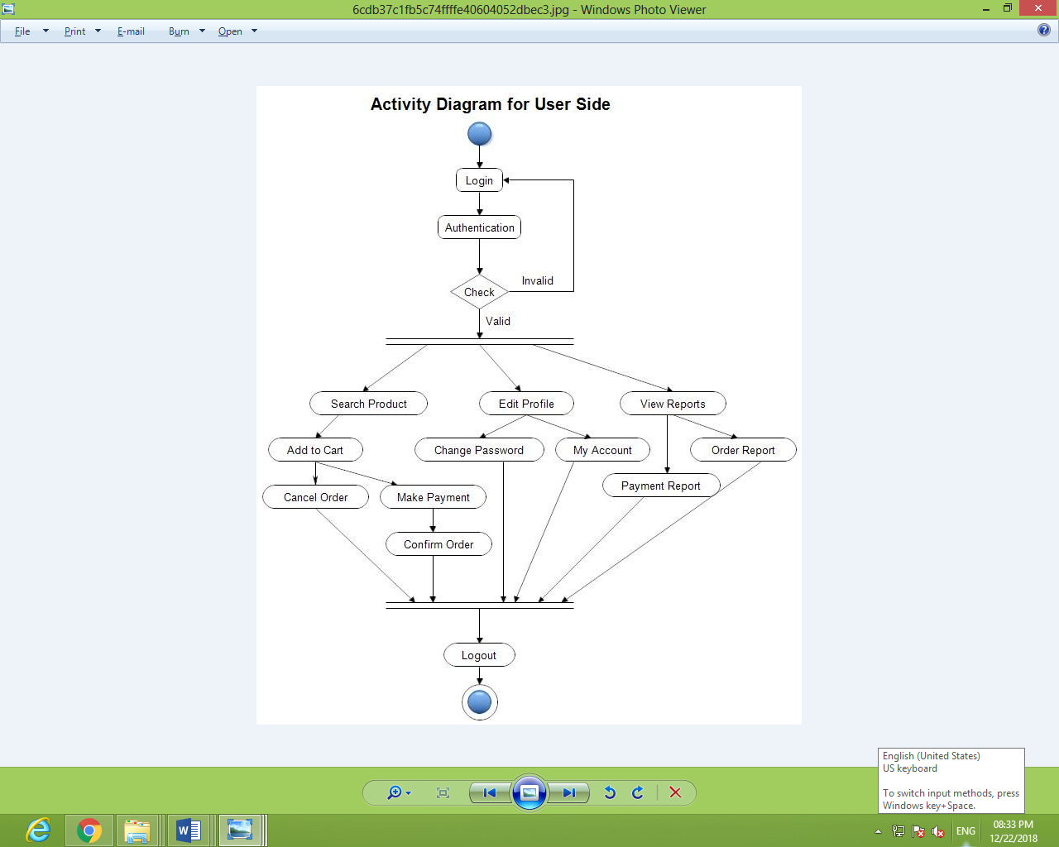

**3.3 Activity Diagram of the Admin side**

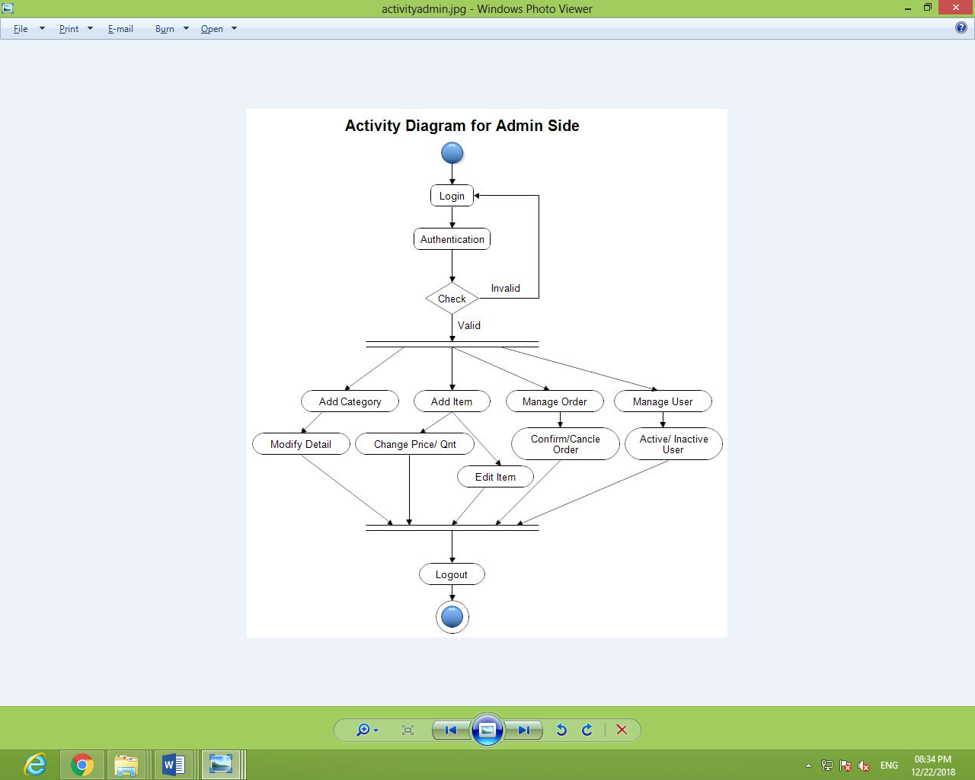

**3.4 Sequence Diagram**

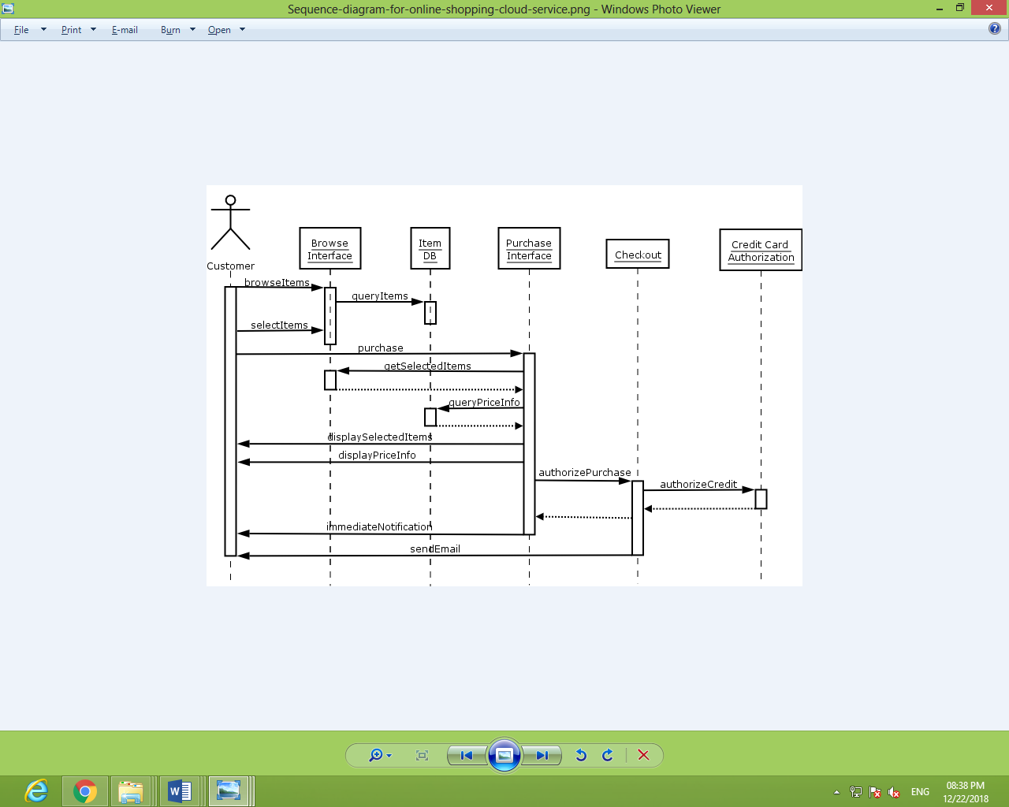

**3.5 Component Diagram**

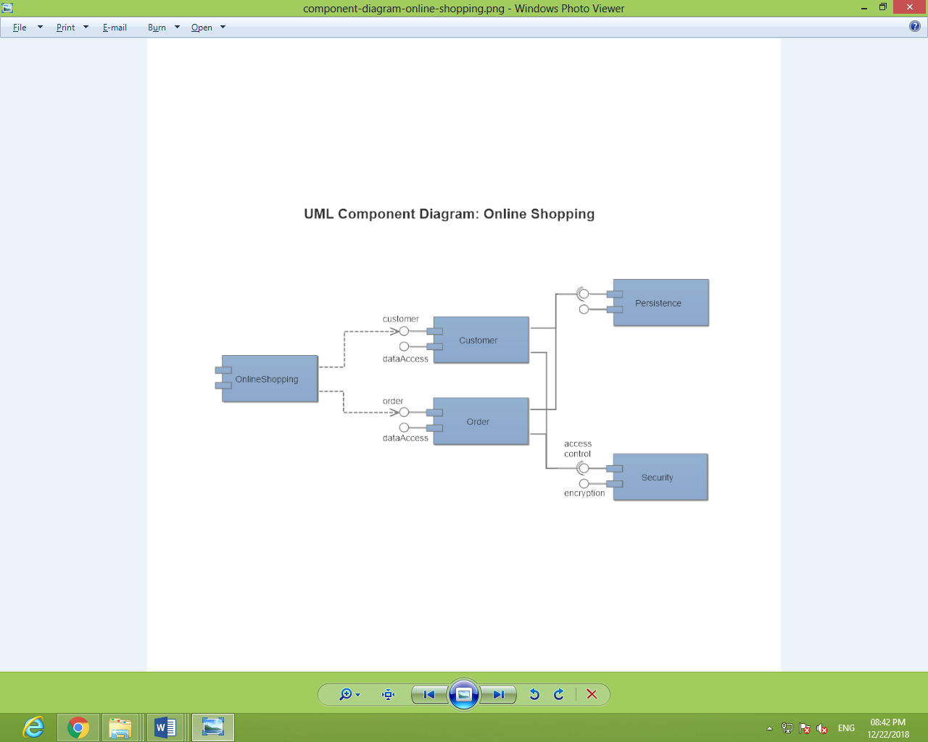

**3.6 State Diagram**

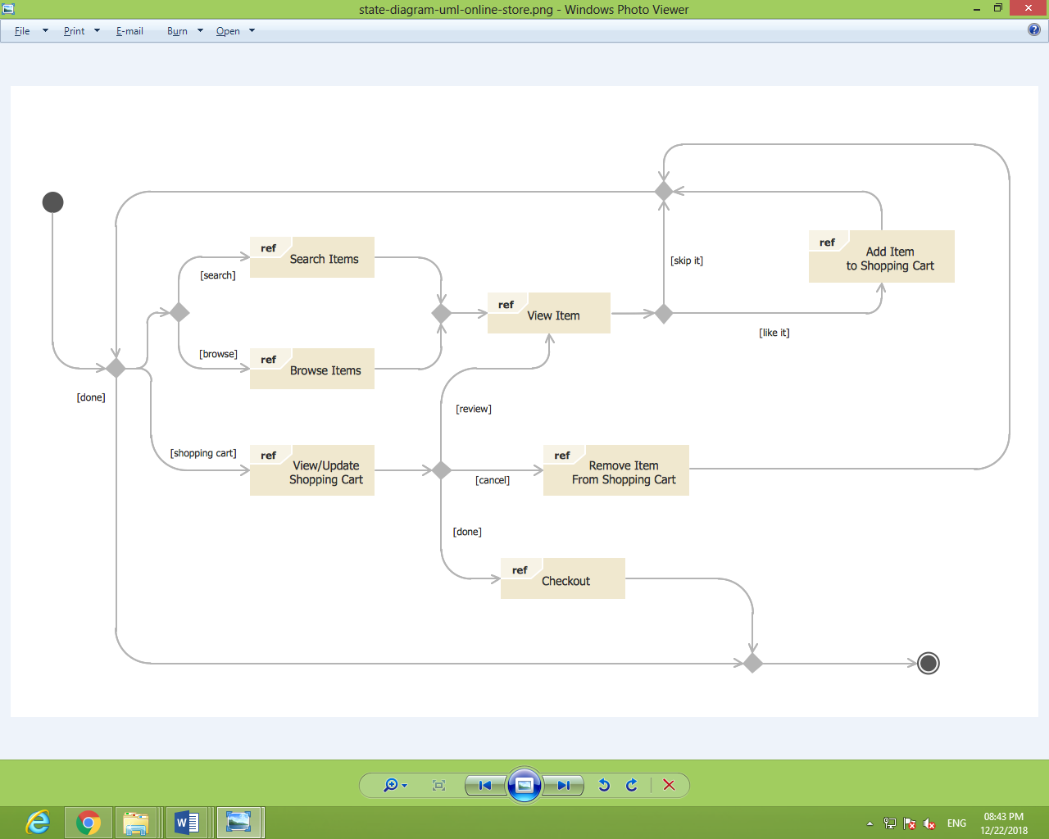

**3.7 Deployment Diagram**

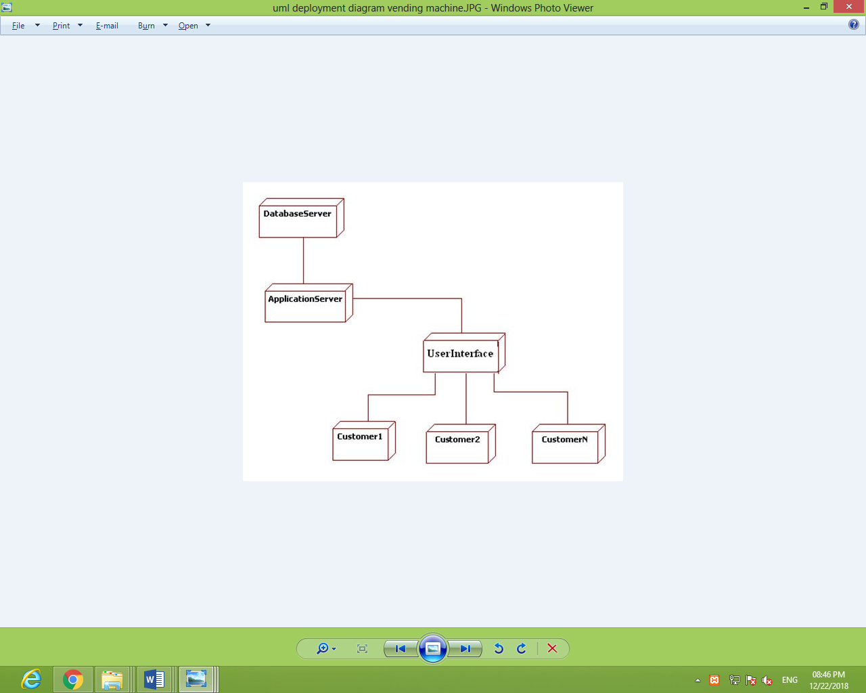

**4. Specific Requirements:**

**4.1 Functional Requirements:**

This section provides requirement overview of the system. Various functional modules that can be implemented by the system will be –

|  |  |  |
| --- | --- | --- |
| **S.No** | **Module** | **Requirement(s)** |
| 4.1.1 | Registration | If customer wants to buy the product then he/she must be registered, unregistered user can’t go to the shopping cart. |
| 4.1.2 | Login | Customer logins to the system by entering valid user id and password for the shopping. |
| 4.1.3 | Changes to Cart | Changes to cart means the customer after login or registration can make order or cancel order of the product from the shopping cart. |
| 4.1.4 | Payment | In this system we are dealing the mode of payment by Cash. We will extend this to credit card, debit card etc. in the future. |
| 4.1.5 | Logout | After ordering or surfing for the product customer has to logout. |
| 4.1.6 | Report Generation | After ordering for the product, the system will be sent one copy of the bill to the customer’s Email-address and another one for the system database. |

**4.2 Non-Functional Requirements:**

Following Non-Functional Requirements will be there in the insurance to the internet:

* Secure access to consumer’s confidential data.
* 24X7 availability.
* Better component design to get better performance at peak time.
* Flexible service-based architecture will be highly desirable for future extension.

On-Functional Requirements define system properties and constraints. Various other Non-Functional Requirements are:

* Security
* Reliability
* Maintainability
* Portability
* Extensibility
* Reusability
* Compatibility
* Resource Utilization

**4.3 Performance Requirements:**

In order to maintain an acceptable speed at maximum number of uploads allowed from a particular customer as any number of users can access to the system at any time. Also, the connections to the servers will be based on the attributes of the user like his location and server will be working 24X7 times.

**4.4 Technic al Issues:**

This system will work on client-server architecture. It will require an internet server and which will be able to run PHP application. The system should support some commonly used browser such as IE, Mozilla, Firefox, chrome etc.

**4.5. Interface Requirement:**

Various interfaces for the product could be

* Login Page
* Registration Form
* There will be a screen displaying information about product that the shop having.
* If the customers select the buy button then another screen of shopping cart will be opened.
* After ordering for the product, the system will send one copy of the bill to the customer’s Email address

**4.6 Software Interface:**

* Operating System: Windows7x/win8x/win10x which supports networking.
* PHP development toolkit.
* MySQL

**4.7 Hardware Interface:**

* Hardware requirements for insurance on internet will be same for both parties which are as follows: Processor: Dual Core
* RAM: 2 GB
* Hard Disk: 320 GB
* Network interface card: The two parties should be connected by LAN or WAN for the communication purpose.